**Assignment on python and mongoDb project**

**Sonakshi Julka- 24MBD008**

**Billing Software:**

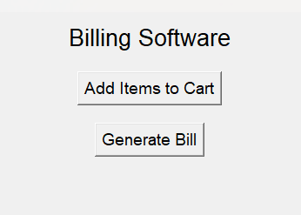

**Add items to cart:**

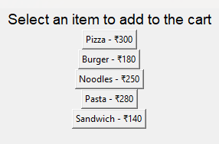

**Bill Details:**

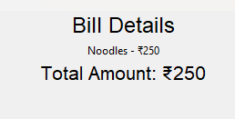

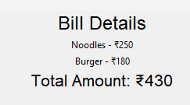

**Data Stored on MongoDb:**

